1. Write an SQL query to check if a given email already exists in the 'users' table before allowing signup, similar to how Zomato or Flipkart prevents duplicate accounts.
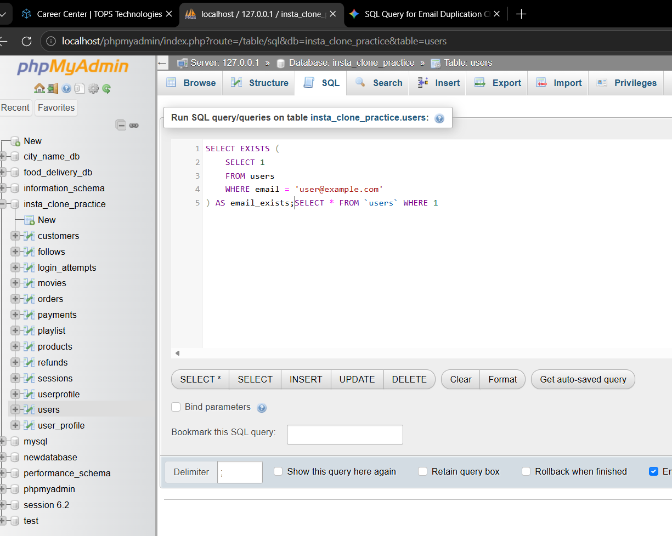
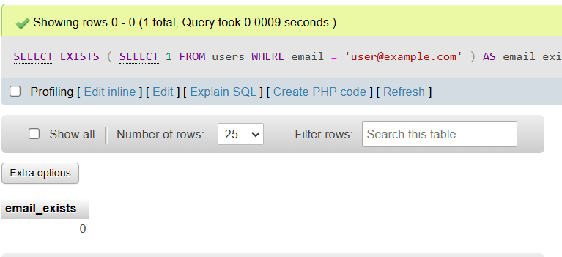
2. After a user signs up, write an SQL query to validate that their username, email, and phone number have been correctly inserted into the 'users' table. Use a SELECT statement with WHERE conditions matching the signup data.

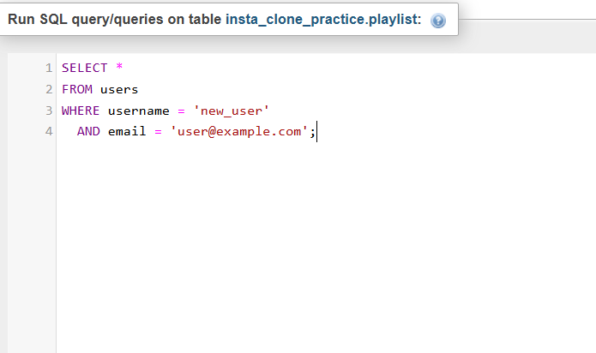
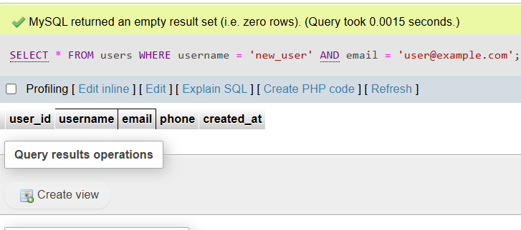

3. During login testing, write an SQL query to fetch the hashed password and account status for a given username from the 'users' table to verify backend authentication logic.
Ans:
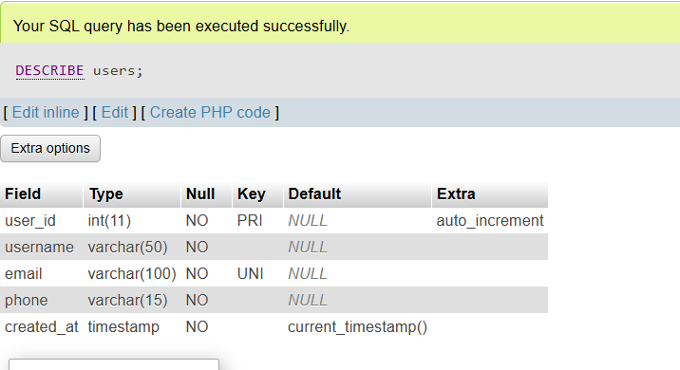

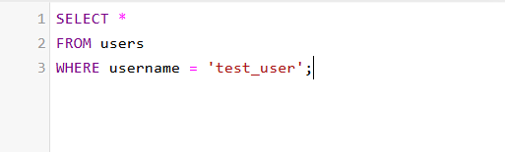

4. Simulate a profile update (like changing your profile picture or bio on Instagram) by writing an SQL UPDATE query to modify the 'profile_pic_url' and 'bio' fields for a specific user in the 'users' table, then write a SELECT query to confirm the update.
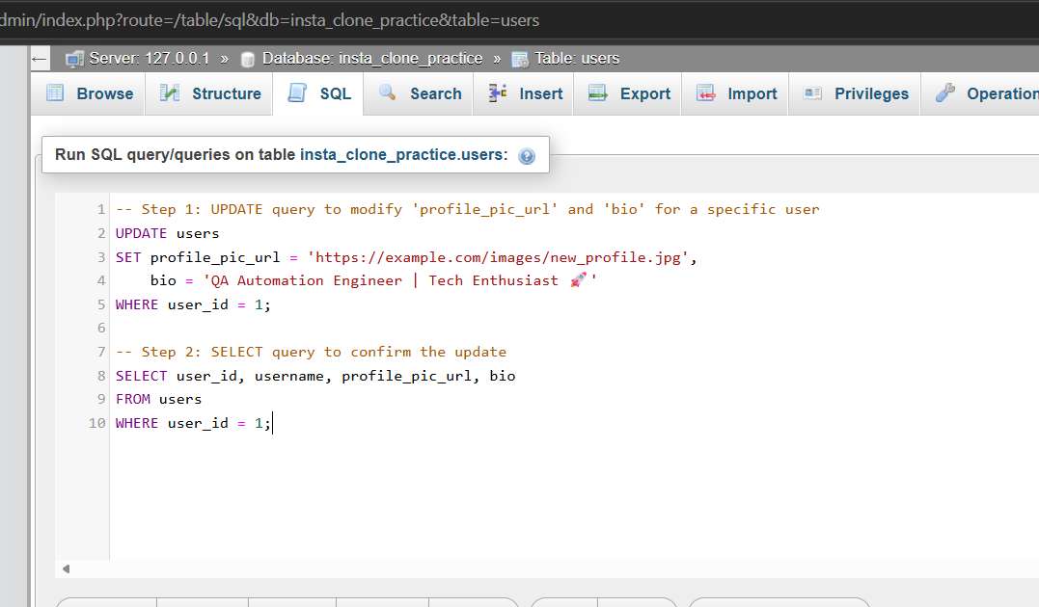
Ans: 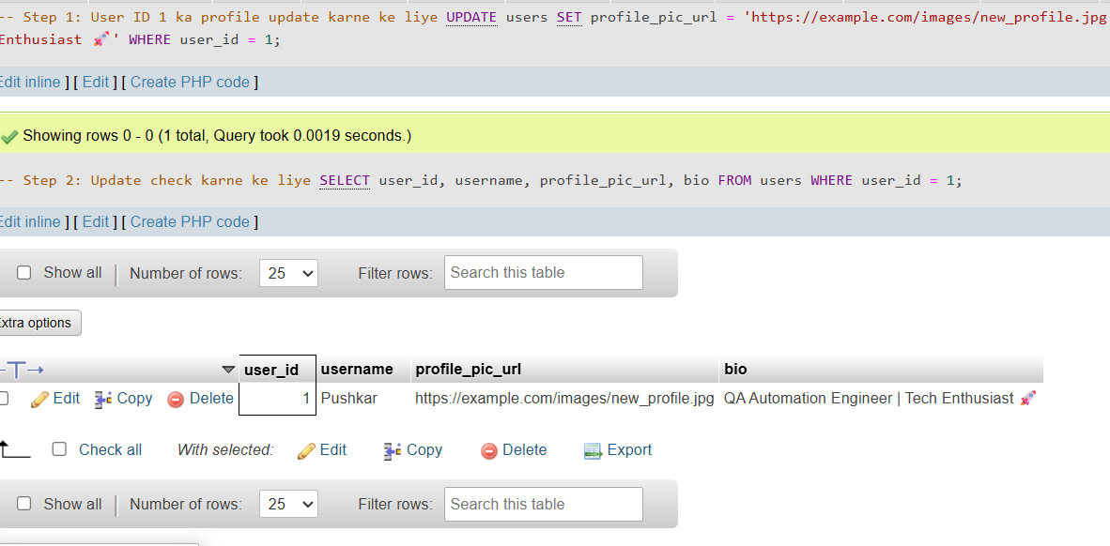

5. Suppose a new feature adds a 'last_login' timestamp column to the 'users' table. Write an SQL query to check which users have not logged in for more than 30 days, as part of post-release database validation. Use the DATE or TIMESTAMP functions in your WHERE clause.
Ans
